Brilliantly digital: The Haiger plant shines through a high level of digitalisation
A factory of the highest calibre:
Rittal’s Haiger plant is the “Factory of the Year 2025”
Haiger, 27 October 2025
This plant is anything but ordinary: Rittal’s factory in Haiger, Hesse, has received a top award. It is the “Factory of the Year 2025” – one of the industry’s highest awards, for more than 30 years it has s only been given only to the best factories in the world. The company achieved the top ranking among all the production companies taking part with its overall victory in the benchmark competition. The jury was particularly impressed by the high level of digitalisation and automation throughout the entire works, as well as the full focus on the customer during every process.

Rittal’s Haiger plant is a pioneering location: In the world market leader’s state-of-the-art factory, up to 9,000 compact enclosures are manufactured rapidly and efficiently every day. After all, the plant is fully digitally integrated. Production is carried out here in an unparalleled way, according to the jury from the management consultancy Kearney and the “Produktion” trade magazine, which has been honouring the world’s best production locations for more than 30 years. They voted the plant “Factory of the Year 2025”.

Here, Industry 4.0 is not merely a buzzword, but reality: production processes are mapped as digital twins, AI tools ensure quality and speed, QR codes continuously ensure transparency and component traceability. A near-perfect planning accuracy of 99.9 per cent and delivery times of 24 hours in Europe and 48 hours worldwide demonstrate the plant’s performance impressively.

End-to-end digitalisation from order to dispatch
The jury was particularly impressed by the continuous end-to-end process chain. What does that mean? All the steps are mapped digitally – from product configuration and automated factory work processes through to packaging. This allows Rittal to produce series and customised products flexibly and at any time. The plant even remained fully operational during the COVID pandemic.

“Our factory shows what is possible when digitalisation is consistently thought through and implemented,” says Jürgen Kromer, plant director at Rittal in Haiger for more than four years and who is fascinated every day by “his” production: “Digitalisation naturally gives us efficiency. Above all, though, we find it important that it offers our customers major benefits – transparency, quality and availability.”

A pioneering spirit and in-house solutions
When the plant was built a few years ago, the pioneering spirit really blossomed, says Mr. Kromer, describing an intense period: “We built many of the systems used in the Haiger plant ourselves. We didn’t wait for someone to supply the technologies we needed for a digitalised factory. We made use of our own expertise and that of our employees, which makes us proud.”

AI testing methods in use
In order to stay ahead of the curve, the team is also promoting AI optimisations in close collaboration with the Rittal Digital Operations department, headed by Moritz Heide: “Artificial intelligence is already successfully aiding quality control, maintenance, our knowledge management, and software analysis.” Through the use of AI, Rittal, for example, has achieved a remarkable 91 per cent first-time pass rate. The jury was also impressed that time-consuming rework was now largely a thing of the past.

“Because our data is available in high quality across the entire value chain, we can use AI in a focused way,” Mr. Heide says: “In engineering, for instance, we are helping our customers become much faster with AI-supported software solutions from our sister company Eplan. At the factory, we minimise errors and complaints using AI tools. The highest data quality and availability throughout the entire process is the standard our customers can expect.”

Commitment to the location
“Through its victory in the main category, Rittal has won the highest award that a production company in Europe can receive,” says Professor Friedhelm Loh, owner and CEO of the Friedhelm Loh Group, of which Rittal is the largest member: “We are very grateful for the jury’s decision to award us this prize. I would also like to thank the Rittal team for making this possible. The plant represents a commitment to Germany and Europe as a production location. It safeguards jobs for employees and their families in our region. And that makes us very proud.”

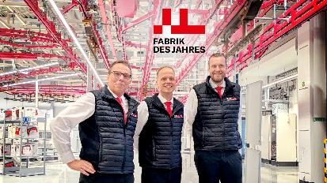 | 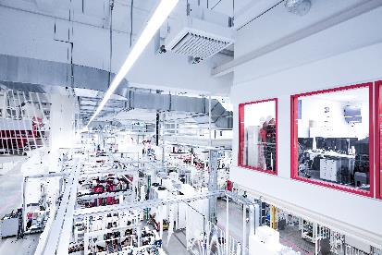
Figure 1: Teamwork in the “Factory of the Year 2025” (from left to right): Jürgen Kromer (Plant Director), Dennis Benfer, Head of Digital Processes / Production Planning, and Moritz Heide, Vice President Rittal Digital Operations. | Figure 2: With the overall victory in the “Factory of the Year 2025” benchmark competition, the Rittal plant in Haiger took the top spot among all the production plants participating and received one of European industry’s highest awards.
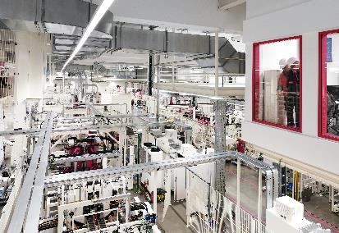 | 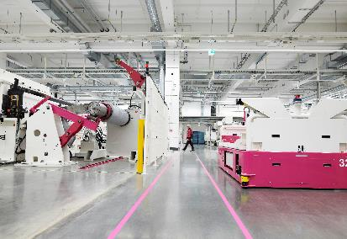
Figure 3: Digitalisation is consistently thought through and implemented here. The result is a continuous end-to-end process chain. | Image 4: Many driverless transport vehicles are also employed at the plant.
May be reproduced free of charge. Please name Rittal GmbH & Co. KG as the source.

Rittal

Rittal is a leading global supplier of enclosure systems, automation and infrastructure with its industrial, IT, energy and power, cooling and service units. Rittal products and solutions are used in over 90% of global industries – standardised, customised, and always of the very best quality.
Our approach and methodology: Rittal, Rittal Software Systems (Eplan, Cideon and German Edge Cloud) and Rittal Automation Systems (RAS, Ehrt, Alfra) combine their hardware and software expertise to streamline, optimise and digitalise processes across the entire value chain for our customers including their IT infrastructure – from control and switchgear construction, machine building to factory operators or the energy sector.
Our delivery promise: Rittal standard products are delivered in Germany within 24 hours, and within 48 hours throughout Europe.
Customer focus
Improving efficiency and increasing productivity through automation and digitalisation is one of the biggest challenges for our customers. This requires in-depth knowledge and expertise, the combination of hardware and software, and cross-sector networking. We are convinced that creating and connecting data rooms is crucial to the success of industrial transformation. And that is exactly our speciality and field of competence.
Eplan and Rittal are driving the development of the digital automation twin, making data accessible and useable in operations as well. Cideon is improving data consistency in the digital product twin context with its CAD/CAM, PDM/PLM and product configuration expertise. German Edge Cloud’s ONCITE Digital Production System (DPS) makes production process data transparent, enabling it to be optimised – right through to energy management using digital production twins.
Sustainability
Environmental and climate protection, social commitment and ethical corporate management are a given for Rittal. We take our responsibility for a sustainable future seriously. Our approach to resource management and conservation involves continuous improvement of our own production processes and ensuring that our products have the lowest possible Product Carbon Footprint. Our solutions support our customers in achieving their own climate targets.
Family business and global player
Founded in 1961, Rittal is the largest company in the owner-operated Friedhelm Loh Group. The group operates worldwide, with 13 production sites and over 95 international subsidiaries. It has more than 12,600 employees and posted revenues of 3.1 billion euros in fiscal 2023. In 2023, the Friedhelm Loh Group was presented with the “Best Place to Learn” and “Employer of the Future” awards. In 2025, Rittal was awarded the Top 100 Seal as one of Germany’s most innovative medium-sized companies for the fourth time in a row.
For more information, visit www.rittal.com and www.friedhelm-loh-group.com.

Corporate Communications
Dr. Carola Hilbrand Rittal GmbH & Co. KG
Corporate & Brand Communications Auf dem Stützelberg
Tel.: 02772/505-2527 35745 Herborn
hilbrand.c@rittal.de www.rittal.com


Follow us:

